WIC Alphabet Worksheet
OARS
Open-Ended Questions:
Open-ended questions encourage deeper conversation because they require more than a “yes” or “no” answer, specific fact, or number. For example, open-ended questions often start with “what,” “tell me,” or “how.” Rewrite each of the following closed questions so that it becomes an open-ended question.
Closed Question | Open-Ended Question
Do you like the way Jonathan eats?
Do you plan on breastfeeding?
Are you happy with your baby’s weight gain so far?

Affirmations:
Affirm participants by finding opportunities to sincerely compliment them on their efforts, making supportive, reinforcing statements, focusing on successes and efforts, and, above all, staying positive! It can be very helpful for participants to feel as if you’re on their side before offering nutrition education. Read the following participant transcript and then write three possible affirmations you could make before offering any guidance.
“My son Jake is a good eater. I’ll usually sit him down for breakfast in the morning while I get ready for work. He eats almost anything I give him, like bananas, frozen waffles, cereal, orange juice, stuff like that. Then I take him to the child care, and I don’t know exactly what they feed him there, but I think its pretty healthy stuff, like sandwiches, fruit, vegetables, milk. I let him pick out a snack in the afternoon from the snack cabinet, so it’ll be something like a bagel, a cereal bar, whatever’s in there. Then lately I’ve been having him help me with dinner, so I’ll have him do things like hand me foods from the fridge, wash vegetables, stir ingredients together. The whole family sits down together at dinner, and I usually try to put together pretty well-balanced dinners, so for example, last night we had: turkey burgers with lettuce, tomatoes, and pineapple, but his favorite is spaghetti.”
Your affirmations:

Reflections:
It’s surprising that simply repeating the words or emphasizing the meaning behind what a participant says can be useful, but it demonstrates that you’re listening carefully to what they say, and want to help them. When participants feel heard, they’re much more likely to be genuine and tell you more. For each statement, write the reflection that you might say in response.
Yeah, the doctor has recommended that I take Erika to the dentist a couple of times, but when I call the dentist, they’re like, ’No we don’t start seeing kids until they’re at least two years old.’

I don’t really want to breastfeed because I tried with the last one, but I didn’t make enough milk, so I just switched to formula.
Aiden is a pretty picky eater when it comes to vegetables. He used to eat a bunch of stuff like carrots, broccoli, and other vegetables, but now he just says, “no carrots” or “no broccoli” whenever I put them on his plate.

Summaries:
Summaries are similar to reflections, but instead of focusing on a specific comment, they capture a list of key ideas. They are a great tool to use whenever a participant tells you a lot of information at one time, and you want to make sure that you understand it all. They are also helpful when you want to review all the information you obtained during the assessment
For this activity, imagine that you just had a participant give you a lot of information at once, and you want to make sure that you understand it all. Read the following transcript and then use the space below to write in what you would say in response as a summary.
“Well, it was kind of scary after Paige was born. I actually just got her home from the NICU a few days ago. She came eight weeks early, and pretty soon after she was born, we found out that she has a heart defect called PDA. I forgot what it stands for, but I know that it just means that she has a hole in her heart. The doctors said that it’s a pretty small-sized hole, so hopefully it will close on its own in a few weeks, but I have to keep an eye on her. I also have an appointment to see her cardiologist again next week. I guess if the hole doesn’t close on its own, they might have to do a surgery and plug up the hole, so we’ll see.”
Your summary:
ABCDE Guide
For this activity, read the following information and then use the provided ABCDE Guide to complete the assessment and answer the questions below.
John comes in to the WIC clinic for Alex’s nutrition education appointment. Alex is 14 months old. The last time he was in for his WIC appointment, he plotted at wt/lgth 76%ile. While in the lab, you ask John what the doctor has said about Alex’s growth, and if he has any medical conditions. John tells you that the doctor is happy with Alex’s growth and he has no medical conditions. When you ask if the doctor has ever recommended a lead test, John states that his doctor said it was not needed since they have lived in a newer home since he was born. When asked about allergies or dental visits, John explains that Alex fell off the couch once and broke his baby tooth and he had an emergency dental visit for that, but has not been to one since, and asks, “Should I be taking him regularly, even though it’s just baby teeth?” While in the lab, you ask if there is any smoking or use of recreational drugs and if he and Alex feel safe at home. John states that there are no concerns regarding drugs or alcohol, and the family is safe at home. However, he does indicate that his mom does live with them, and she smokes, but she is very good about only smoking outside on the patio. When you then ask if Alex takes medications, John says he does not take any medications except for Tylenol once in a while if he is feeling under the weather, no actual medications that have been prescribed by the doctor. John states that even though Alex’s doctor says he is growing well, he is really concerned with transitioning him to table foods and getting him off the bottle. He says he will continue to offer the two bottles of formula (8 ounces per bottle), one in the morning and one at night, until he feels like he is eating more table foods and his variety is not so limited. He offers table foods two times per day but he doesn’t seem interested in them. He always has Alex pick out what he wants to eat to try to get him more interested in food. John says Alex drinks 2-3 ounces of whole milk per day and one cup of juice, all offered in a sippy cup.
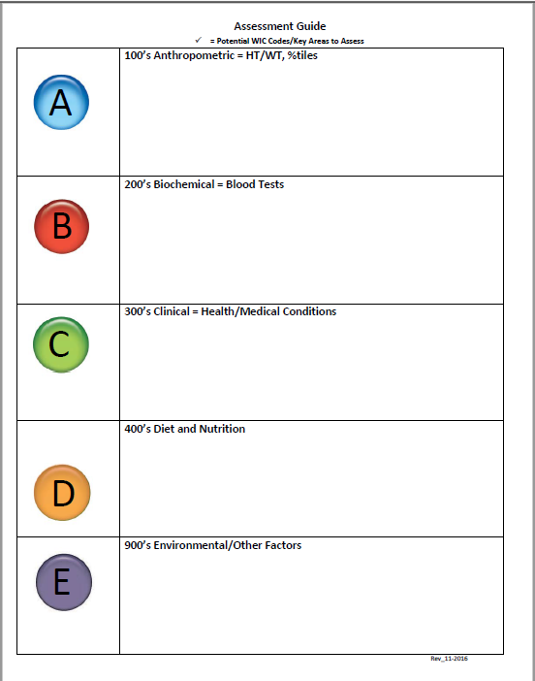

In looking at your ABCDE Guide:
What is missing from A: Anthropometric? | What is the best way to ask the participant for  this information?

What is missing from B: Biochemical? | What is the best way to ask the participant for  this information?

What is missing from C: Clinical? | What is the best way to ask the participant for  this information?

What is missing from D: Diet and Nutrition? | What is the best way to ask the participant for  this information?

What is missing from E: Environmental? | What is the best way to ask the participant for  this information?
Write what you would say to summarize what you have learned from the assessment back to the participant?

Did you discover any red flags or risk codes while completing your ABCDE assessment?

What nutrition education and referrals would you consider providing to this participant? Are you required to offer a referral to the RD or Nutritionist and, if so, why?

Explore – Offer – Explore
Choose two of the clients listed in the chart below to make an EOE sandwich for:

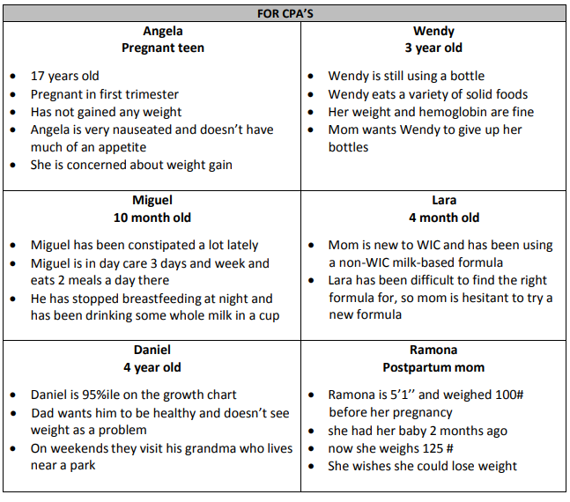
#1 Name:
Explore: (What she knows, has heard, or would like to know

Offer: (Ask Permission, Be brief)

Explore: (What she thinks or how she can use this info)

#2 Name:
Explore: (What she knows, has heard, or would like to know

Offer: (Ask Permission, Be brief)

Explore: (What she thinks or how she can use this info)

TGIF
Next to each of the following statements, indicate in which part of the TGIF note they belong: T, G, I, or F. If the statement does not belong in the note, put N/A.
Note: In the TGIF format, the T stands for tool, G stands for goals, I stands for important information, and F stands for follow-up.
- Code 353 was assigned for peanut allergy __ __
- Participant feels unsure about what to eat during pregnancy __ __
- Referred to Registered Dietitian for next appt. __ __
- Mother weighs 130 pounds today __ __
- Dad started offering juice to his infant because the doctor said it would help with constipation __ __
- Mother wants to try a new veggie for her infant every week __ __
- Mother wants to breastfeed, but is worried she won’t have time when she goes back to work __ __
- Child drinks soda 2-3/week ____
- The doctor said child was lactose intolerant so dad has been giving her lactose-free milk, but she can still eat cheese __ __
- Follow up on mealtimes and milk intake __ __
- Infant drinks 2-3 ounces of Similac Neosure every 3 hours ____
- Mother will try putting frozen fruit in her water to make it more drinkable __ __

Write a TGIF Note based on the case study below. (HINT: You can use the ABCDE Guide you created on page _____ to assist)
John comes in to the WIC clinic for Alex’s nutrition education appointment. Alex is 14 months old. The last time he was in for his WIC appointment, he plotted at wt/lgth 76%ile. While in the lab, you ask John what the doctor has said about Alex’s growth, and if he has any medical conditions. John tells you that the doctor is happy with Alex’s growth and he has no medical conditions. When you ask if the doctor has ever recommended a lead test, John states that his doctor said it was not needed since they have lived in a newer home since he was born. When asked about allergies or dental visits, John explains that Alex fell off the couch once and broke his baby tooth and he had an emergency dental visit for that, but has not been to one since, and asks, “Should I be taking him regularly, even though it’s just baby teeth?” While in the lab, you ask if there is any smoking or use of recreational drugs and if he and Alex feel safe at home. John states that there are no concerns regarding drugs or alcohol, and the family is safe at home. However, he does indicate that his mom does live with them, and she smokes, but she is very good about only smoking outside on the patio. When you then ask if Alex takes medications, John says he does not take any medications except for Tylenol once in a while if he is feeling under the weather, no actual medications that have been prescribed by the doctor. John states that even though Alex’s doctor says he is growing well, he is really concerned with transitioning him to table foods and getting him off the bottle. He says he will continue to offer the two bottles of formula (8 ounces per bottle), one in the morning and one at night, until he feels like he is eating more table foods and his variety is not so limited. He offers table foods two times per day but he doesn’t seem interested in them. He always has Alex pick out what he wants to eat to try to get him more interested in food. John says Alex drinks 2-3 ounces of whole milk per day and one cup of juice, all offered in a sippy cup.
T:

G:

I:

F:
Bring It All Together
Review the information below. Complete the ABCDE Guide and TGIF for the
Victoria is a 28-year-old woman who is pregnant with her first child. She is in the WIC clinic today for her first certification appointment.
After you greet Victoria, you escort her back to your office. You verify her eligibility to participate in the WIC Program after collecting all of her family, individual, and income information. You escort her to the lab and, while there, you record her current height, weight (168.5 pounds), and hemoglobin 12.2.
Back in your office, she tells you her pre-pregnancy weight was 162 pounds (pre-pregnancy BMI = 29.2 (overweight)), indicating that her pregnancy weight gain to date is 6.5 pounds (which is within the normal pregnancy weight gain range). During the rest of your assessment, you discover the following information:
- She has had three visits with her OBGYN since she discovered that she was pregnant.
- She was diagnosed with diabetes seven years ago. She is under the care of a health care professional, and takes Glyburide Acyclovir for glucose control.
- She has untreated dental caries and has no dental provider.
- She never feels down, depressed, or hopeless, and never has little interest or pleasure in
doing things.
- She has an allergy to pineapple and strawberries, but doesn’t have any problem avoiding
those foods.
- She takes a daily prenatal vitamin.
- She eats three meals (breakfast, lunch, dinner, and two snacks).
- She states she does not like to eat beans or peanut butter, grapes or oranges.
- She is not picky about the milk and she drinks whole, 2%, 1%, and skim milk; she also drinks water, fruit juice, soda, diet soda, and herbal tea.
- She eats meats, but mostly chicken and not every day.
- When it comes to vegetables, she mostly eats canned corn, green beans, and peas, but she doesn’t eat many, and wishes she knew how to prepare different kinds.
- Many of her close friends and family members have breastfed their babies, and she plans on breastfeeding too with their help.
- She doesn’t have any concerns about smoking tobacco products, drugs, or alcohol, and feels safe in her relationship. She does, however, inform you that she usually smokes two marijuana cigarettes daily.

After completing the assessment, review the completed ABCDE.
Write what you would say to summarize what you have learned from the assessment back to the participant?

Did you discover any red flags or risk codes while completing your ABCDE assessment?

What nutrition education would you consider offering to this participant? How would you introduce the options?

Complete the Note based on the information that you gathered:
T:

G:

I:

F:

